**FARMA CAIS**

Abirami.S #1, Deepika.M#2, Padmahpriya.S#3,Kalaiselvi .V.K.G#4

*#1#2#3 Student, Department of Information Technology*

*#4Assistant Professor, Department of Information Technology*

*#1#2#3#4 Sri Sairam Engineering College ,West Tambaram,Chennai_600044*

*Affiliated to Anna University,Tamil Nadu ,India.*

[#1abitha.sk.1190@gmail.com](mailto:#1abitha.sk.1190@gmail.com) [#2deepikamohan78@gmail.com](mailto:#2deepikamohan78@gmail.com) [#3spriyasundar98@gmail.com](mailto:#3spriyasundar98@gmail.com) [#4kalaiselvi.it@sairam.edu.in](mailto:#4kalaiselvi.it@sairam.edu.in)

**ABSTRACT-**

**The primary occupation in our country is farming. Management of work done and cost production products was one of the issue in this industry. Farming is becoming a more time-critical and information-intense business. A push towards higher productivity will require an information-based decision -making agricultural system . A dynamic growth of mobile communication technology is creating opportunities for economic growth, social empowerment, and grassroots innovation in developing countries. Mobile plays vital role in day today life of farmers as well as other people.**

**The proposed system deals with an android application which monitores the workers/farmers, knowing the work duration, recording the quantity of the product obtained, verifying the health condition of the worker, track the duration of the work done by the workers. Smart irrigation process is enhanced, temperature and humidity will be known , soil and seed quality is analyzed, water level in the field is monitored and Flood alertness will be intimated through this application via notification. The fund details and the list of banks which provide the fund for the farmers will be displayed on the application. Interest calculation of the fund will also be available on the application.**

**Keywords: Pulse-rate sensor, Arduinouno, Arduino Ethernet, Seed sensor, Moisture sensor, Water level sensor, Load cell , Humidity sensor , Light sensor , GPRS module , Android Application.**

I.INTRODUCTION:

Agriculture is defined as an art, science and business of producing crops and livestock for economic purposes. It accounts for about 15% of the total export earnings and provides raw material to a large number of Industries (textiles, silk, sugar, rice, flour mills, milk products). It is a difficult task for the farmer to manage the production and also the products produced .When the seeds are not in a good quality it is being wasted .

Natural disaster are recurrent phenomenon in India, but chronically Flood disaster is one of them. Frequent occurrence of floods affects agricultural output. Crop losses is estimated around 0.18 percent of GDP. Apart from the flood disaster impact, weather variation has significantly reduced crop yield in India. Irrigation is important infrastructure for developing agriculture. Rainfall and Water availability in India has huge Regional imbalance. We suffer from Sub-Optimal utilization of created facilities. India’s irrigation efficiency is very poor. We have a faulty Groundwater policy, competing demand for water is increasing rapidly. Overexploitation of surface water leading to drainage problems.

The recent implementation include eAgriculture which uses the electronic equipment and IT based application to provide a major push to the ease the agriculture practices. There are several advantages in using such applications if and only if those does not affect or alter the nature of the crop by the radiations or by any other means.

II.RELATED WORK:

A. Spray Guide:

The Spray Guide app calculates the amount of solute, the amount of solvent, the mixing time and spraying areas.

Drawbacks**:**

It shares their experience including data and result with others over their social accounts but does not support all the functionalities like quality of seeds is not intimated in this application.

B. CC Mobile app:

The CC Mobile app can track health metabolic metrics and read the environment metrics like temperature,humidity.

Drawbacks:

In this app, the fund details which is the main source for the farmers and his family was not included.

C. Modern Agricultural Aid:

The Modern Agriculture Aid app include a way for the farmers to authenticate himself and to maintain the details of his production.

Drawbacks:

In this app, the irrigation process is not enhanced and the water level in the field is not monitored.

III.LITERTURE SURVEY

The farming pattern of current scenario includes more than one person working on the same row of farm field. So, there is no rule of one section per worker to farm on. The current way of farming doesn’t have any sensors embedded on the farm field to monitor or maintain the level of crops but it ensures to reduce the work of landlord in monitoring both the farmers and the farm field. The duration of work done by the farmers is to be known in order to pay them according to their work and also the profit is to be calculated from the income and the expenditure. The profit calculation is done for their own survival. The income and expenditure of production is not handled by the landlords. Thus, each product information must be documented for future usage.

IV .PROPOSED SYSTEM

The proposed system aims in developing the welfare of the farmer by the application .The application will include a way for thefarmer to authenticate himself and to maintain the details of his production ,maintaining and managing the production records. The system also include three devices, one that helps in authenticating the farmer and tracking the person’s location . The duration of the work was done in the field is measured and it also ensures that the farmers are in normal health condition according to the result of checking his/her health rate. Second device stays helpful in maintain the quantity of the sack of crop produced and directly saving it into the database for the future reference. The third device says the farmers about the temperature and humitidy , soil and the seed quality that they know what kind of soil can be used for what kind of seed can cultivate in the field is analysed by this device and intimated to the application . An interface device which gives the intimation about the nature diasters(FLOOD) and the alertness will be intimated through the application via notification. The funds details and the list of banks which provide the fund for the farmer will be displayed on the application. Interest calculation of the fund will also available on the application.

Fig 1:Android app

ANDROID APPLICATION

DATABASE

ANTHENTICATE

TEMP& HUM

EXPENDITURE

HEALTH RATE

QUANTITY MEASURE

CROP CHAR

FUND DETAIL & BANKS

PROFIT ANALYSIS

IRRIGATION

The android application authenticate the user by login and register himself .The user can check the crop characteristics and also the land area characteristics and choose the crop that he wishes to grow in the field .Enter the expenditure spend for the purpose. The details get saved in the database for future reference .The user will also get the quantity of the product and the profit calculation of the works. The user will get updated of the person entering the field and also the person exiting the same with the help of the RFID and beacon module at the remote end. The farmer needs to anthenticate himself when he enters the field and should also check the health with the help of RFID/button and the pulse rate sensor respectively. The device includes a button to anthenticate the user even if the user forget the RFID. The user is given a slave beacon module and the device includes a master beacon module. The application consist of the temperature and humidity measures. The irrigation process detail is also included in the application. The application will be always in ALL REGIONAL LANGUAGES and it also have the VOICE RECOGNITION.

V.SYSTEM ARCHITECTURE

The system has the ARM7 microcontroller. This microcontroller has the TDMI-S processor. It is 32 bit microcontroller and also have the pipeline process. RFID receiver is interfaced to the microcontroller through the UART protocol. It is used to check whether the user is a valid person or not.If the user is a valid person it will check the heartbeat of the person. Pulserate sensor used to measure the heartbeat and is interfaced to the microcontroller through the external interrupt. All the information is updated to the web server through GPRS modem. Beacon module checks the valid person is the present or not at that particular area.

Fig 2:Device to anthenticate

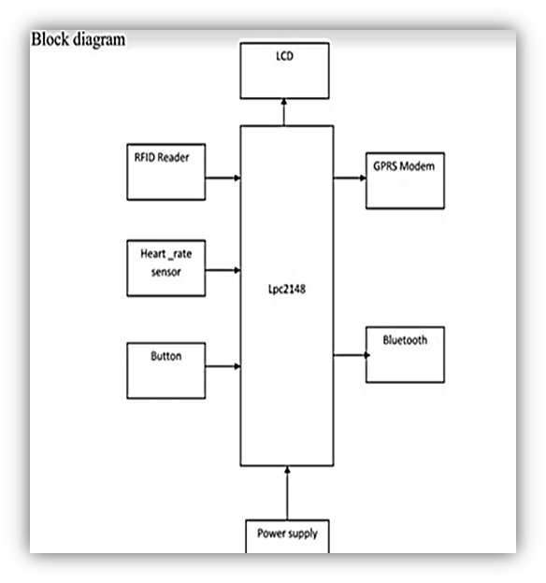

The second device includes a load cell, HX711,Arduino UNO, Arduino Ethernet Shield to measure the quantity of the product and send it to the online server. The load cell varies in measurements like 1kg, 3kg, 10 kg, 40 kg, 100kg etc .The Hx711 helps in connecting the load cell and Arduino. Uno is the interactive electronic objects and is open source microcontroller board developed by arduino cc. The Arduino UNO is interconnected with Arduino Ethernet shield it connects the Arduino to connect to the internet in mere minutes.

Fig 3: Device to measure quantity

Arduinoethernet shield

Load cell

Arduino UNO

Hx711

The third device includes the sensors that moisture sensor,

Light sensor ,Humidity sensor, Temperature sensor and GPRS modem. It uses the lcd display to display the details to the farmers. The power supply is connected to the microcontroller RX64 GR-Kaede to relay then to the motor for the working

Fig 4:Device to measure the temp, hum , moisture.

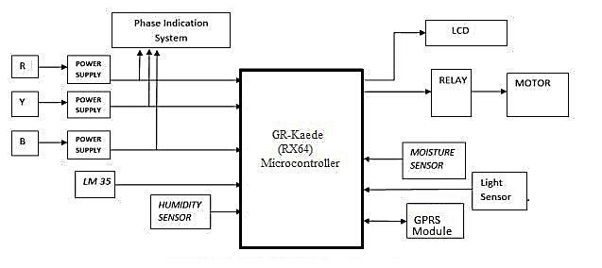

VI.COMMERCIAL VIABILITY

This type of application is not been implemented yet. It ensures to pay the workers only for the work done by them and assures the profit for workers.This will be of feasible cost expenditure.

VII.CONCLUSION:

Technology is a path towards bright that cuts darkness and promotes the lives of the people. A better aid for agriculture is given by the upcoming technologies. There are many applications related to agriculture to increase the work speed and also ensures smart work in short period of time.

This system approaches that the application is built at low cost and it is a user friendly and also assures profit in work. It also gives the fund details needed by the farmers.

**REFERENCE:**

[1] Scenario of IT based Agriculture Projects Volume 8, No. 1, Jan-Feb 2017 International Journal of Advanced Research in Computer Science ISSN No. 0976-5697

[2] <http://claroenergy.in/top-10-apps-revolutionizing-indian-agriculture/>

[3] IOT Based Smart Agriculture Monitoring System by Dr.N.Suma, Sandra Rhea Samson, S.Saranya, G.Shanmugapriya5 R.Subhashri International Journal on Recent and Innovation Trends in Computing and Communication ISSN: 2321-8169 Volume: 5 Issue: 2 177 – 181